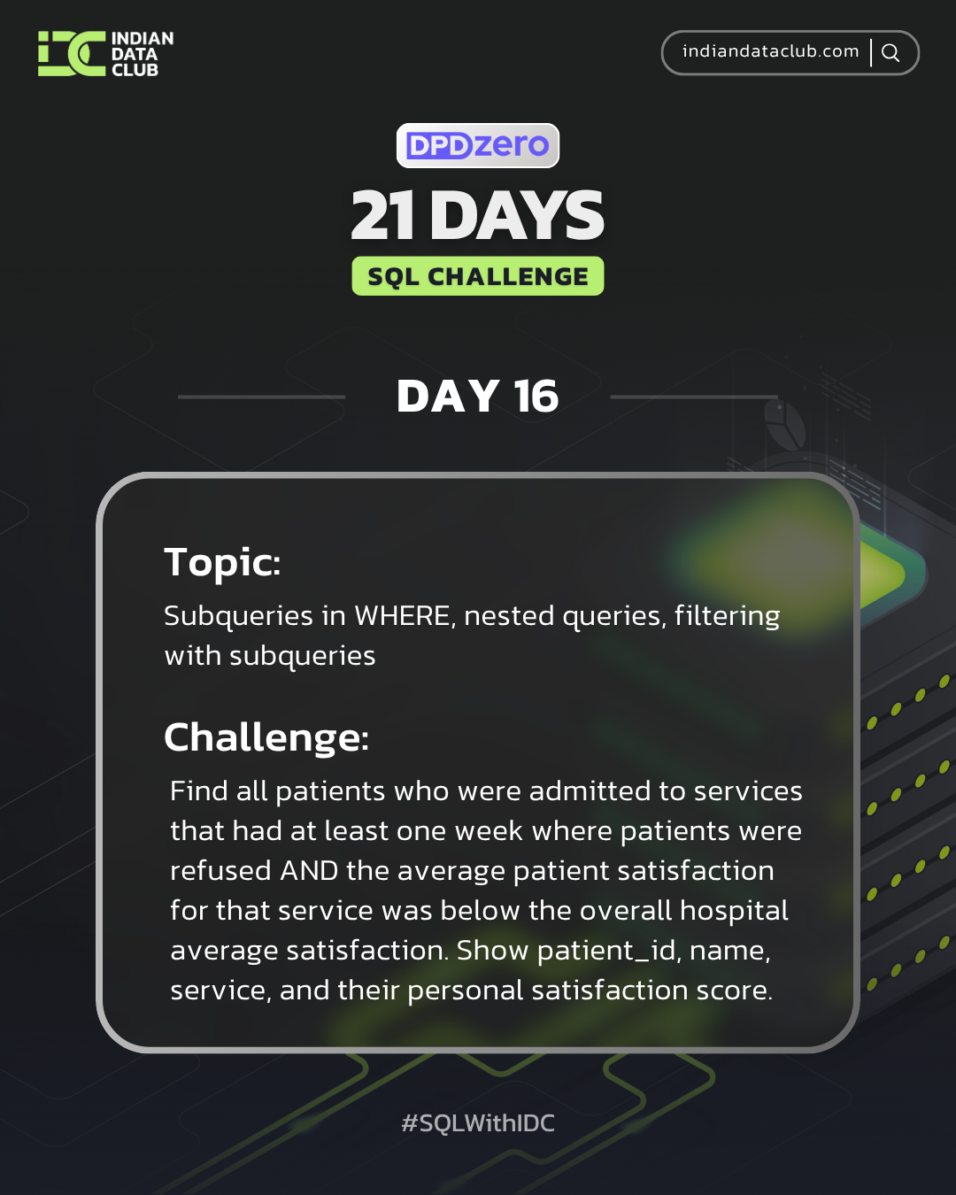
Day-16 SQL Challenge
Day-16 Challenge:
Find all patients who were admitted to services that had at least one week where patients were refused AND the average patient satisfaction for that service was below the overall hospital average satisfaction. Show patient_id, name, service, and their personal satisfaction score.
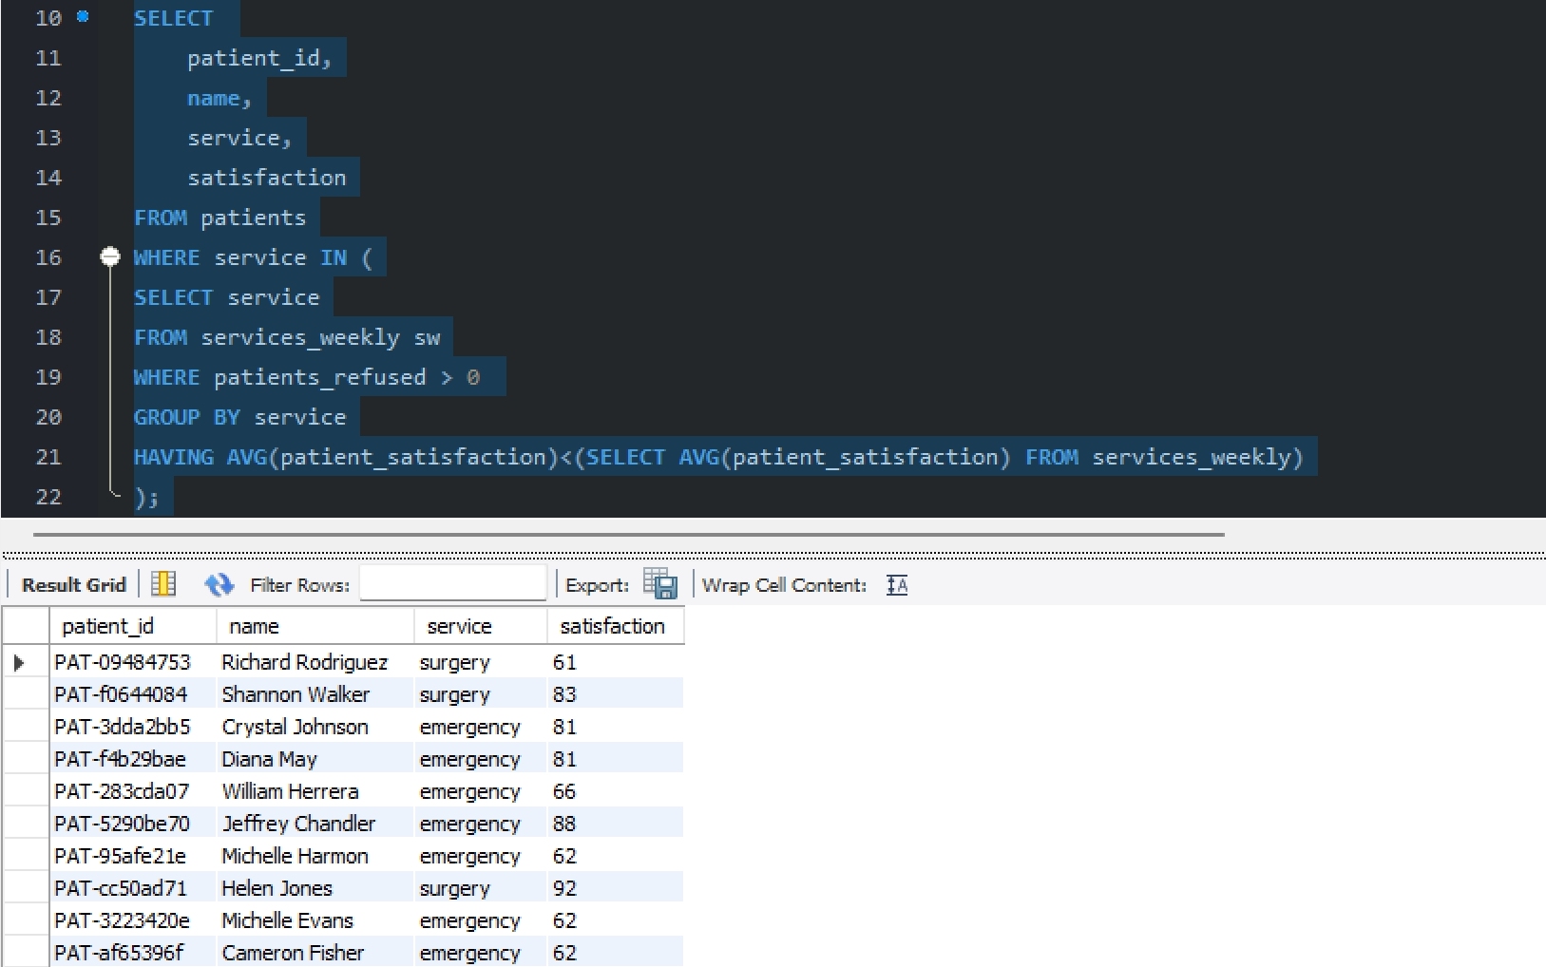
Practice Questions:
1. Find patients who are in services with above-average staff count.
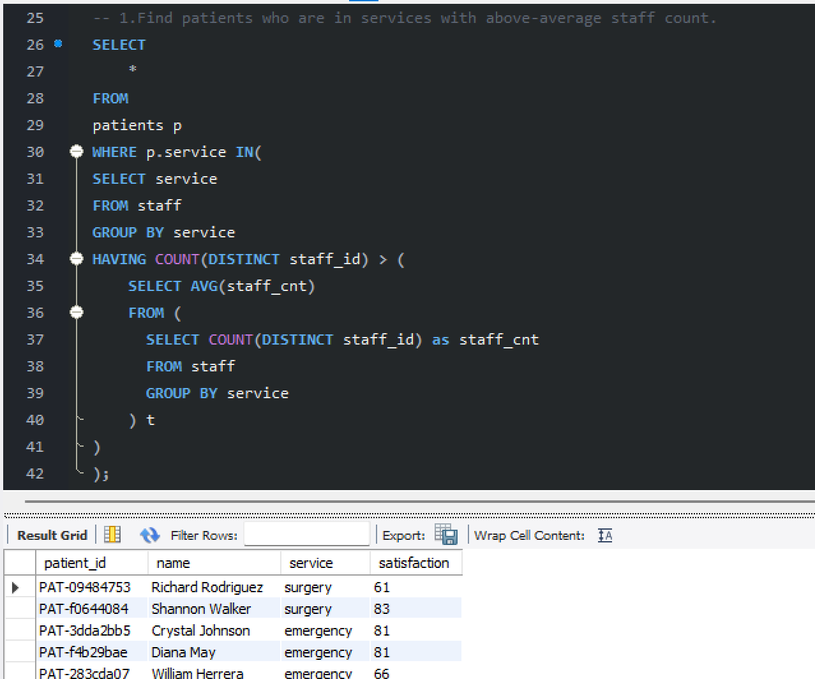
2. List staff who work in services that had any week with patient satisfaction below 70.
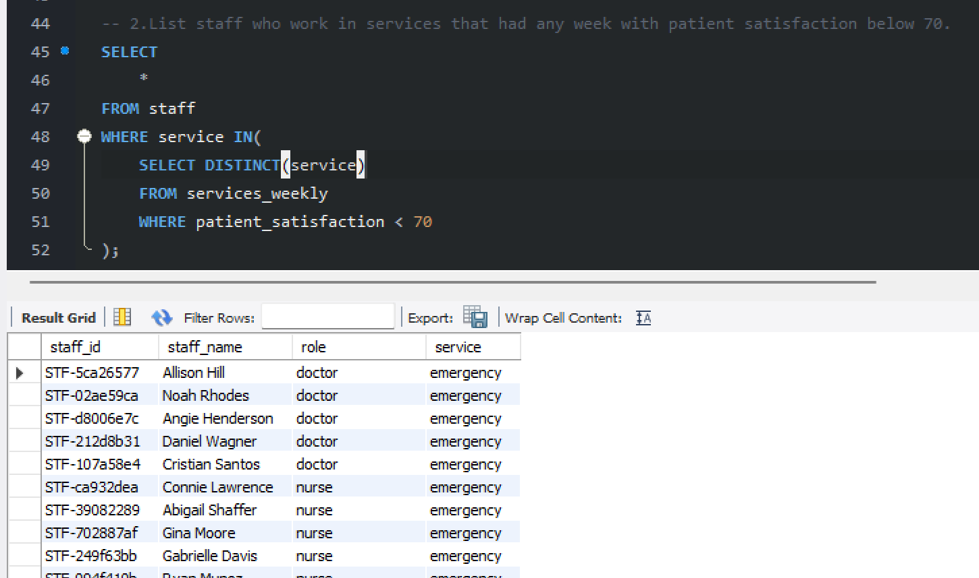

3. Show patients from services where total admitted patients exceed 1000.
